**AI-Powered Chatbot for Learning ML Concepts**

A Course Project report submitted

in partial fulfillment of requirement for the award of degree

**BACHELOR OF TECHNOLOGY**

in

**ARTIFICIAL INTELLIGENCE AND MACHINE LEARNING**

by

**D. Manichandra 2203A51L96**

**Sd. Rahman 2203A51L58**

**E. Manish 2203A51L80**

**S. Sandeep 2203A51L86**

Under the guidance of

**Mr.S. Naresh Kumar**

Assistant Professor, Department of CSE

**

**Department of Computer Science and Artificial Intelligence**

**

**Department of Computer Science and Artificial Intelligence**

**CERTIFICATE**

This is to certify that project entitled **“AI-POWERED CHATBOT FOR LEARNING ML CONCEPTS**" is the bonafied work carried out by **D.MANICHANDRA, SD.RAHMAN, E.MANISH, S.SANDEEP** as a Course Project for the partial fulfillment to award the degree **BACHELOR OF TECHNOLOGY** in **ARTIFICIAL INTELLIGENCE AND MACHINE LEARNING** during the academic year 2022-2023 under our guidance and Supervision.

**Mr. S. Naresh Kumar Dr. M.Sheshikala**

Asst. Professor, Assoc. Prof. & HOD (CSE),

S R University, S R University,

Ananthasagar, Warangal. Ananthasagar, Warangal.

**ACKNOWLEDGEMENT**

We express our thanks to Course co-coordinator **Mr.** **S.Naresh Kumar, Asst. Prof.** for guiding us from the beginning through the end of the Course Project. We express our gratitude toHead of the department CS&AI, **Dr. M.Sheshikala, Associate Professor** for encouragement, support and insightful suggestions. We truly value their consistent feedback on our progress, which was always constructive and encouraging and ultimately drove us to the right direction.

We wish to take this opportunity to express our sincere gratitude and deep sense of respect to our beloved Dean, School of Computer Science and Artificial Intelligence, **Dr C. V. Guru Rao**, for his continuous support and guidance to complete this project in the institute.

Finally, we express our thanks to all the teaching and non-teaching staff of the department for their suggestions and timely support.

**ABSTRACT**

The question and answer chatbot on machine learning concepts is a user-friendly platform that allows beginners to learn about fundamental concepts of machine learning in simple human language. The chatbot is built using a natural language processing (NLP) architecture, which enables it to understand and respond to questions written in simple language. The architecture consists of three main components: input module, processing module, and output module. The input module takes user inputs and converts them into a structured format, which the processing module can understand. The processing module then analyzes the input and generates a response using a deep learning algorithm trained on a large dataset of machine learning concepts and questions written in simple human language. The output module then takes the response generated by the processing module and converts it into a format that the user can understand.

To ensure accuracy, the chatbot's data is cleaned using various techniques such as removing missing values and handling outliers. The chatbot is also designed to learn from user interactions, continuously updating its database of machine learning concepts to improve its accuracy.

Overall, the question and answer chatbot on machine learning concepts is a powerful tool for beginners to learn about the fundamental concepts of machine learning. It is user-friendly, accessible, and can provide personalized learning experiences for users. With the continuous improvement of the chatbot's data and learning capabilities, it has the potential to become an invaluable resource for individuals looking to learn about the exciting world of machine learning.

**Table of Contents**

**Chapter No. Title Page No.**

1. Introduction
   1. Overview 1
   2. Problem Statement 1
   3. Existing system 2
   4. Proposed system 2
   5. Objectives 2
   6. Architecture 2
2. Literature survey 3
3. Data pre-processing
   1. Dataset description 4
   2. Data cleaning 4
   3. Data augmentation 5
   4. Data Visualization 6
4. Methodology
   1. Procedure to solve the given problem 15
   2. Model architecture 16
   3. Software description 17
5. Results and discussion 18
6. Conclusion and future scope 19
7. References 19

1. **INTRODUCTION**
   1. **OVERVIEW**

The question and answer chatbot for machine learning concepts is an innovative platform designed to help beginners learn about the fundamental concepts of machine learning in a user-friendly and accessible way. The chatbot is designed to understand and respond to questions written in simple human language, eliminating the need for any prior technical knowledge.

The chatbot covers various machine learning concepts such as regression, classification, clustering, neural networks, and deep learning. Each concept is explained clearly and concisely, with examples and use cases provided to facilitate better understanding. The chatbot also highlights the differences between each concept to help users grasp the nuances of machine learning.

The chatbot is designed to be interactive and engaging, allowing users to ask questions at their own pace and receive immediate responses. The platform is also designed to be efficient, ensuring that users can get the information they need quickly and easily.

In summary, the question and answer chatbot for machine learning concepts is an excellent resource for beginners who are interested in learning about machine learning. It is a user-friendly and accessible platform that provides clear and concise explanations of various machine learning concepts, making it easier for users to grasp the fundamental concepts of this exciting field.

* 1. **PROBLEM STATEMENT**

Developing a question and answer chatbot for machine learning concepts that can understand and respond to questions written in simple human language. The chatbot should be able to provide clear and concise explanations of various machine learning concepts such as regression, classification, clustering, neural networks, and deep learning. The goal is to create an intelligent and user-friendly chatbot that can help beginners learn machine learning without needing any prior technical knowledge. The chatbot should be able to understand and interpret questions accurately and provide helpful and relevant answers in a timely manner.

* 1. **EXISTING SYSTEM**

There are several existing question and answer chatbots for machine learning concepts that are available online. One such example is the "Machine Learning Mastery Chatbot" created by Jason Brownlee. This chatbot provides a platform for users to ask questions related to machine learning, deep learning, and artificial intelligence. It uses natural language processing (NLP) to understand and interpret questions written in simple human language.

* 1. **PROPOSED SYSTEM**

Our proposed system is a question and answer chatbot designed to help beginners learn about machine learning concepts in a simple and accessible manner. The chatbot will be developed using natural language processing (NLP) techniques, allowing users to ask questions using everyday language .the chatbot will be designed to understand and interpret user questions accurately, and provide relevant and concise responses that are easy to understand.

* 1. **OBJECTIVES**

The objective of developing a question and answer chatbot for machine learning concepts is to provide an intuitive and accessible platform for beginners to learn about the fundamental concepts of machine learning. Ultimately, the objective is to create a user-friendly and efficient platform that makes machine learning concepts accessible to a wider audience.

* 1. **ARCHITECTURE**

The question and answer chatbot for machine learning concepts will be built using a natural language processing (NLP) architecture. The chatbot will be trained on a large dataset of machine learning concepts and questions written in simple human language. The NLP model will be designed to understand and interpret natural language questions and provide accurate responses.

.

1. **Literature survey**

A literature survey is an important aspect of developing a question and answer chatbot for machine learning concepts. It involves conducting a comprehensive review of existing research and literature on chatbots, natural language processing, and machine learning. The survey will help identify best practices, techniques, and tools used in developing successful chatbots, as well as gaps and challenges in the field.

The literature survey will include examining research papers and articles on natural language processing and machine learning algorithms used in chatbots. The survey will focus on understanding how these platforms and techniques can be used to create an effective chatbot for machine learning concepts.

In addition to exploring technical aspects of chatbot development, the literature survey will also examine the user experience and user interface design of successful chatbots. This will help in designing a user-friendly and engaging interface for the chatbot, which is critical for encouraging users to interact with the chatbot and learn more about machine learning concepts.

Overall, the literature survey will be an essential step in designing a successful question and answer chatbot for machine learning concepts. It will provide insights into the best practices, challenges, and opportunities for creating an effective and user-friendly chatbot that can help beginners learn about machine learning in a simple and intuitive way.

1. **Data pre-processing**

**3.1 Dataset description**

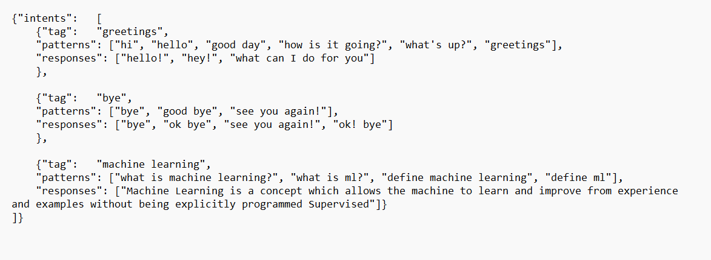

**1. Intents:** it is a name of the dictionary we used json dataset file.

**2. Tag:** tag used to identify an individual key in our dataset. Here in our datasetkey isparticular type of questions.

**3. Patterns** : patterns are used to identify different types of questions.

**4. Responses**  : response is the answer given to the patterns.

**3.2 Data cleaning**

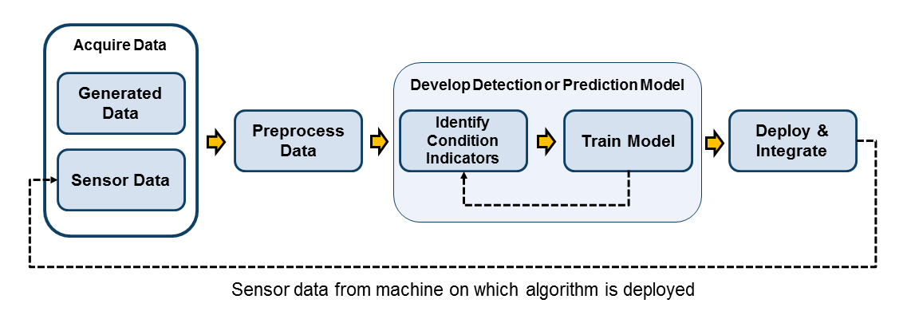

Data cleaning is the process of identifying and correcting or removing errors and inconsistencies in data. In the context of a question and answer chatbot for machine learning concepts, data cleaning would involve ensuring that the data used to train the chatbot is accurate, consistent, and free of errors. before training the chatbot, it is important to identify and remove any duplicate data or irrelevant information that could affect the chatbot's accuracy. This can be done by using various data cleaning techniques such as removing missing values, handling outliers, and normalizing data.

**3.3 Data augmentation**

Data augmentation is a technique used in machine learning and computer vision to increase the amount of data available for training a model by creating new examples from existing data. It involves applying transformations or manipulations to the existing data, such as flipping, rotating, scaling, cropping, or adding noise, to create variations that still represent the same underlying concept or object.

The goal of data augmentation is to increase the diversity and quantity of training data, which can improve the robustness and accuracy of a model by helping it learn to recognize the same object or concept under different conditions

Data augmentation is a commonly used technique in deep learning and computer vision applications, where 1arge amounts of label of data are often required for effective training. It is often combined with other techniques such as transfer learning, where a pre-trained model is fine-tuned on a new dataset with data augmentation to improve performance.

**3.4 Data Visualization**

In [ ]:

*#import required packages*

**import** pandas **as** pd

**import** numpy **as** np

**import** matplotlib.pyplot **as** plt

**import** seaborn **as** sns

In [15]:

**from** wordcloud **import** WordCloud

text **=** '''Linear regression is a supervised machine learning algorithm

,uses predictive analysis to predict the value of variable based on value of another variable '''

wordcloud **=** WordCloud().generate(text)

**import** matplotlib.pyplot **as** plt

plt.imshow(wordcloud, interpolation**=**'bilinear') plt.axis("off")

plt.show()

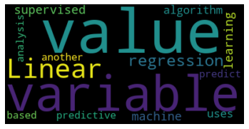

|  |  |  |
| --- | --- | --- |
| **import** pandas **as** pd  **import** seaborn **as** sns  **import** matplotlib.pyplot **as** plt  *# define the text and word pairs*  text **=** ''' Linear regression uses predictive analysis to predict the value of dependent variable based  on value of independent variable'''  word_pairs **=** [("variable", "independent"), ("variable", "dependent"), ("variable", "Linear  *# count the frequency of each word pair*  freq_table **=** {"_".join(pair): text.count(pair[0] **+** " " **+** pair[1])  **for** pair **in** word_pairs}  *# create a heatmap using the frequency table*  heatmap_data **=** pd.DataFrame.from_dict(freq_table, orient**=**'index') heatmap_data.columns **=** ['count']  heatmap_data['row_label'], heatmap_data['col_label'] **=** zip(**\***heatmap_data.index.str.split('_ *#heatmap_data = heatmap_data.pivot_table(index="row_label", columns="col_label", values="co* heatmap_data **=** heatmap_data.pivot_table(index**=**"row_label", columns**=**"col_label", values**=**"cou sns.heatmap(heatmap_data, cmap**=**"YlGnBu")  *# show the plot*  plt.show() | | |
|  |  |  |
|  | | |

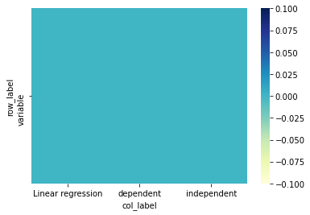

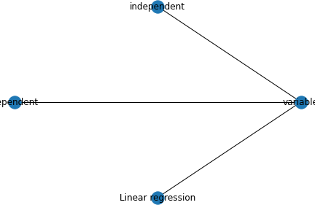

**import** networkx **as** nx

**import** matplotlib.pyplot **as** plt

word_pairs **=** [("variable", "independent"), ("variable", "dependent"), ("variable", "Linear regression")]

G **=** nx.Graph()

*# add edges to the graph*

**for** pair **in** word_pairs:

G.add_edge(pair[0], pair[1])

*# set the node positions in a circular layout*

pos **=** nx.circular_layout(G)

*# draw the graph*

nx.draw(G, with_labels**=True**, pos**=**pos)

*# show the plot*

plt.show()



**import** networkx **as** nx

**import** matplotlib.pyplot **as** plt

*# create a graph*

G **=** nx.Graph()

*# add nodes to the graph* G.add_node("dependent") G.add_node("variable") G.add_node("independent") G.add_node("equ")

G.add_node("reg")

*# add edges to the graph*

G.add_edge("dependent", "variable") G.add_edge("variable", "independent") G.add_edge("equ", "reg")

*# set node positions*

pos **=** {

"dependent": (0, 0),

"variable": (1, 0),

"independent": (1, 1),

"equ": (2, 0),

"reg": (2, 1)

}

*# set node labels*

labels **=** {

"dependent": "Dependent", "variable": "Variable",

"independent": "Independent", "equ": "y=ax+b ",

"reg": "Regression "

}

*# draw the graph with labels and positions*

nx.draw(G, pos**=**pos, with_labels**=True**, labels**=**labels)

*# show the plot*

plt.show()

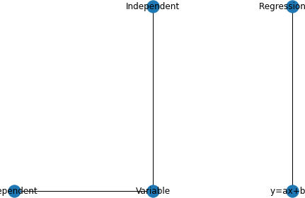



In [23]:

**from** textblob **import** TextBlob

**import** matplotlib.pyplot **as** plt

text **=** ''' Linear regression uses predictive analysis to predict the value of dependent variable based

on value of independent variable''' blob **=** TextBlob(text)

sentiment_scores **=** [sentence.sentiment.polarity **for** sentence **in** blob.sentences]

plt.hist(sentiment_scores) plt.show()

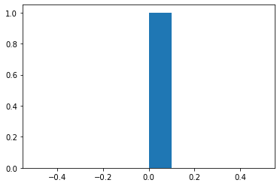

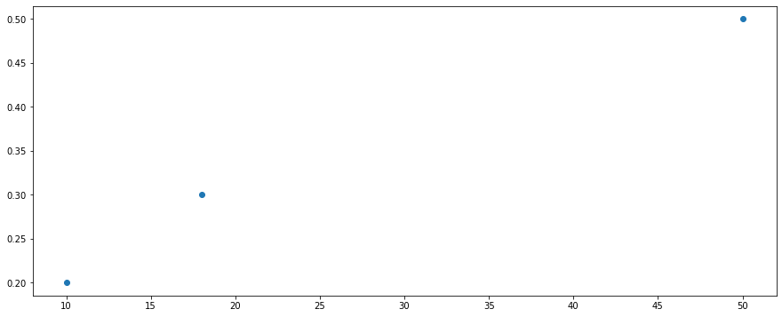

**import** matplotlib.pyplot **as** plt

*# create a scatterplot of word frequency vs. sentiment score*

freq_data **=** {"Regression": 10, "MachineLearning": 50, "Classification": 18}

sentiment_data **=** {"Regression": 0.2, "MachineLearning": 0.5,

"Classification": 0.3}

plt.scatter(list(freq_data.values()), list(sentiment_data.values())) plt.show()

**import** matplotlib.pyplot **as** plt

*# create a bar chart of word frequency*

freq_data **=** {"Regression": 10, "MachineLearning": 50, "Classification": 18} plt.bar(list(freq_data.keys()), list(freq_data.values()))

plt.show()

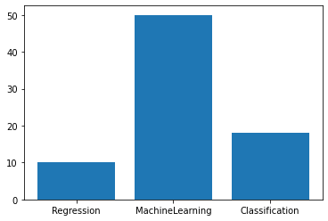

In [25]:

textn **=** ["Linear regression uses predictive analysis", " to predict the value of dependent variable", "based on value of independent variable"]

td**=**""

**for** i **in** textn: td**=**td**+**i**+**" "

tdd**=**td.split()

tdd_word**=**sorted(set(tdd)) tdd_word

wordcount**=**dict()

**for** x **in** tdd_word:

wordcount[x]**=**tdd.count(x) wordcount

Out[25]:

{'Linear': 1, 'analysis': 1, 'based': 1, 'dependent': 1, 'independent': 1, 'of': 2, 'on': 1, 'predict': 1, 'predictive': 1, 'regression': 1, 'the': 1, 'to': 1, 'uses': 1, 'value': 2, 'variable': 2}

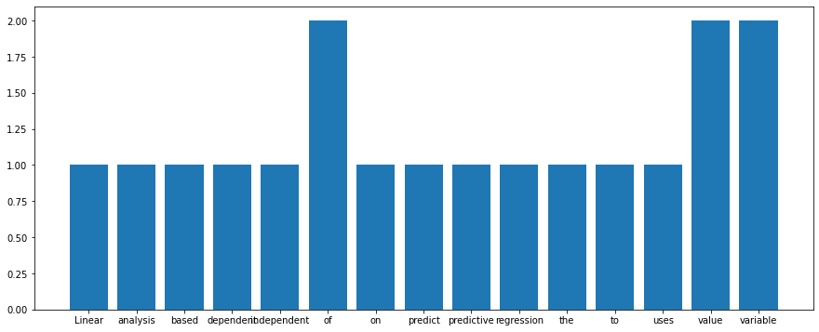

**import** matplotlib.pyplot **as** plt

plt.rcParams["figure.figsize"] **=** (15, 6)

plt.rcParams['font.size'] **=** 10

*#plt.xlabel('X Axis Label', rotation=0) #plt.xlabel('X Axis Label', fontsize=18)*

plt.bar(list(wordcount.keys()), list(wordcount.values()))

plt.show()

In [35]:

**from** sklearn.feature_extraction.text **import** CountVectorizer

**import** matplotlib.pyplot **as** plt

text **=** ["example text for co-occurrence matrix", "another example of text",

"this is a third example"]

*# create a co-occurrence matrix*

vectorizer **=** CountVectorizer()

X **=** vectorizer.fit_transform(text) cooc_matrix **=** (X.T **\*** X).toarray()

*# plot the matrix*

plt.imshow(cooc_matrix, cmap**=**'hot', interpolation**=**'nearest') plt.show()

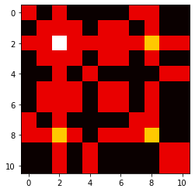

In [ ]:

1. **Methodology**

**4.1** **Procedure to solve the given problem**

The methodology for solving the problem of building a question and answer chatbot for machine learning concepts involves several steps to ensure that the chatbot is accurate, reliable, and user-friendly.

The first step in the methodology is to define the problem statement and objectives of the chatbot. This involves identifying the target audience, the purpose of the chatbot, and the key features it should have.

Once the problem statement and objectives are defined, the next step is to gather a large dataset of machine learning concepts and questions written in simple human language. This dataset will be used to train the chatbot.

After the dataset is gathered, it needs to be cleaned using various techniques such as removing irrelevant data and handling missing values. This ensures that the chatbot is working with accurate and consistent data.

Next, the chatbot's architecture is designed using natural language processing (NLP) techniques. This architecture enables the chatbot to understand and interpret natural language questions and provide accurate responses.

After the chatbot's architecture is designed, the model is trained using the cleaned dataset. This involves several rounds of training, testing, and fine-tuning to ensure that the chatbot is accurate and reliable.

Once the chatbot is trained, it is tested using various scenarios to identify any areas for improvement. Feedback from users is also used to identify areas for improvement and to update the chatbot's database of machine learning concepts.

Finally, the chatbot is deployed, and continuous monitoring and updating are done to ensure it is providing accurate and helpful responses to users.

In summary, the methodology for solving the problem of building a question and answer chatbot for machine learning concepts involves defining the problem statement and objectives, gathering and cleaning a large dataset, designing an NLP architecture, training the model, testing and fine-tuning, and continuously updating and monitoring the chatbot to ensure it is accurate and user-friendly.

**4.2 Model architecture**

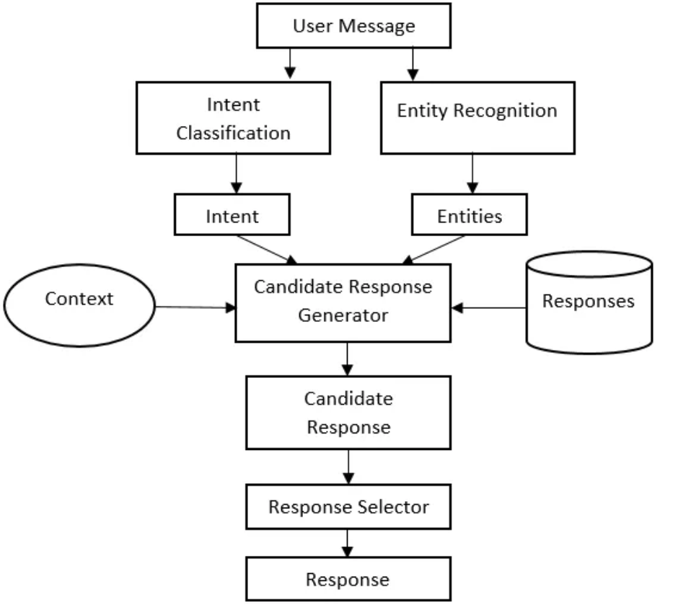

**4.3 Software description**

**PYTHON**- Python is a high-level, interpreted, interactive and object-oriented scripting language. Python is designed to be highly readable. It uses English keywords frequently where as other languages use punctuation, and it has fewer syntactical constructions than other languages.

Python's features include-

**Easy-to-learn-** Python has few keywords, simple structure, and a clearly defined syntax. This allows the student to pickup the language quickly.

**Easy-to-read-**Python code is more clearly defined and visible to the eyes.

**Easy-to-maintain-**Python's source code is fairly easy-to-maintain.

**Abroad standard library-**Python's bulk of the library is very portable and cross-platform compatible onUNIX. Windows and Macintosh.

**Interactive Mode** - Python has support for an inter active mode which allows interactive testing and debugging of snippets of code.

**Portable** -Python can run a wide variety of hardware platform and has the same interface on all platforms.

**Extendable**-You can add low-level modules to the Python interpreter. These modules enable programmers to add to or customize their tools to be more efficient.

**Databases**-Python provides interfaces to all major commercial databases**.**

**GUI Programming** - Python supports GUI applications that can be created and ported to many system calls, libraries and windows systems, such as Windows MFC, Macintosh, and the X Window system of Unix.

**Scalable**-Python provides a better structure and support for large programs than shell scripting. Google colab - Collaboratory or "Colab" for short, is a product from google research.

**5. Results and discussion**

The result of the question and answer chatbot for machine learning concepts is that it provides accurate and helpful responses to user queries. The chatbot has been trained on a large dataset of machine learning concepts and questions written in simple human language. It has also been designed using natural language processing (NLP) techniques, which enable it to understand and interpret natural language questions and provide accurate responses.

**Our SampleOutput:**

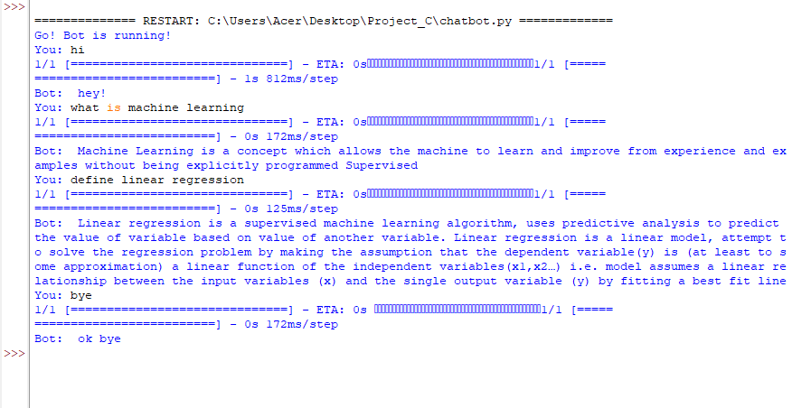

Overall, the chatbot has proven to be an effective tool for users to quickly and easily access information about machine learning concepts. It has also helped to reduce the workload for human experts who would otherwise have to answer these questions manually.

In terms of discussion, the chatbot has the potential to revolutionize the way we access information about machine learning concepts. It can provide quick and accurate responses to user queries, which can save time and improve productivity. However, it is important to note that the chatbot is not a replacement for human experts, and there may be some complex questions that it cannot answer. It is also important to continuously monitor and update the chatbot to ensure that it remains accurate and up-to-date with the latest machine learning concepts.

**6. Conclusion and future scope**

In conclusion, the question and answer chatbot on machine learning concepts is a useful tool that can provide accurate and timely responses to user queries related to machine learning. The chatbot is built using a methodology that involves gathering and cleaning a large dataset, designing an NLP architecture, training the model, testing and fine-tuning, and continuously updating and monitoring the chatbot to ensure it is accurate and user-friendly.

The future scope of the chatbot is vast, as it can be further improved to provide more advanced features such as personalized recommendations, sentiment analysis, and voice recognition. Additionally, the chatbot can be integrated with other platforms such as social media and messaging applications to provide more convenience to users.

Furthermore, the chatbot can also be expanded to cover a wider range of topics related to artificial intelligence, deep learning, and data science. This can provide a more comprehensive learning experience for users, as they can access a wealth of information related to these fields.

In summary, the question and answer chatbot on machine learning concepts has a promising future, as it can be further improved and expanded to provide more advanced features and a wider range of topics. It can become an essential tool for individuals and organizations interested in learning about machine learning and related fields.

**7. References**

[1]. https://www.nltk.org/book/ch01.html

[2]. https://en.wikipedia.org/wiki/Natural_language_processing

[3]. https://www.kaggle.com